Youngsville Public Library: 1st Annual Geranium Fundraiser

Plan ahead now for next year’s planting: 4” pot size!
Order Now – January 9, 2019
Advantages to ordering from YPL now you’ll:
(1) be guaranteed to have enough of the color(s) you need for next year’s planting.
(2) get a great bargain per flat of geraniums & help support Youngsville Library too.

Pick-up date: Saturday, May 18, 2019 weekend after Mother’s Day
1:00 – 3:00 pm at Youngsville Public Library

100 Broad Street, Youngsville, PA 16371 (814)-563-7670 www.YoungsvillePublicLibrary.org

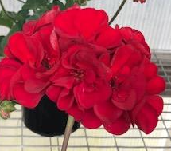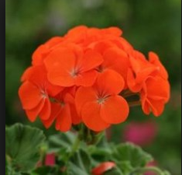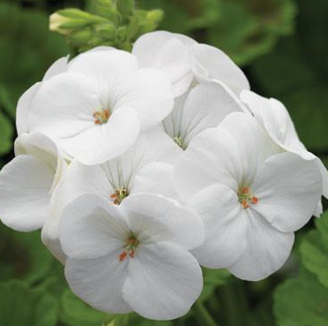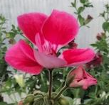
RED TANGO WHITE HOT PINK

Best prices in town!

1 flat* of (8) 4” Pot -Size Geraniums:
only $30.00 per flat
(this price includes tax)

(8 geraniums per flat = $3.75 per 4” geranium-pot, tax included)

Using a local grower to benefit the community too.

*sold in same-color flats only, but can mix & match with a friend
- payment required at time of order, all sales final

---- ------ ---- ----- ------- ------ ----- ------ KEEP TOP PORTION FOR YOUR RECORDS ---- ------ ------ ---- ------- ------ ------ ---
Please print:

__________________________________ ______________________________
Name (first & last) phone/cell number

____________________________________________________________________
Street address city/town State Zip Code
Turn in order & payment
at YPL by 01/09/19
(or postmarked by 12/31/18)
Make Check Payable to:
Youngsville Public Library

Mail to: Youngsville Public Library
100 Broad St. Youngsville, PA
16371
Grand Total Due to YPL
$
Sub-TOTALS
Unit Price
$30.00

$30.00

$30.00

$30.00
COLOR
Red

Tango

White

Hot Pink
QUANTITY
DESCRIPTION
1 FLAT of (8) 4” pot-size geraniums

1 FLAT of (8) 4” pot-size geraniums

1 FLAT of (8) 4” pot-size geraniums

1 FLAT of (8) 4” pot-size geraniums

